Date

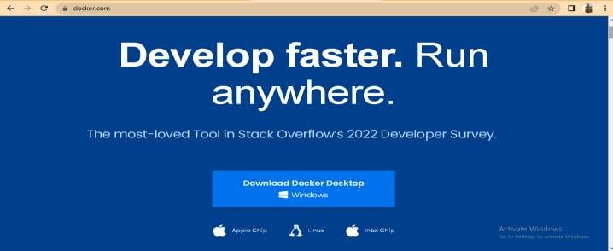

**Setting up Application Environment**

**Docker CLI Installation**

10

NOVEMBER

2022

Batch ID

PNT2022TMID31532

Project Name

Skill/Job Recommender Application

**Step 1. Download Docker from docker.com and install it by running the Docker**

Desktop Installer.exe file

**Step 2. Goto hub.docker.com register and create an account and login with the same**

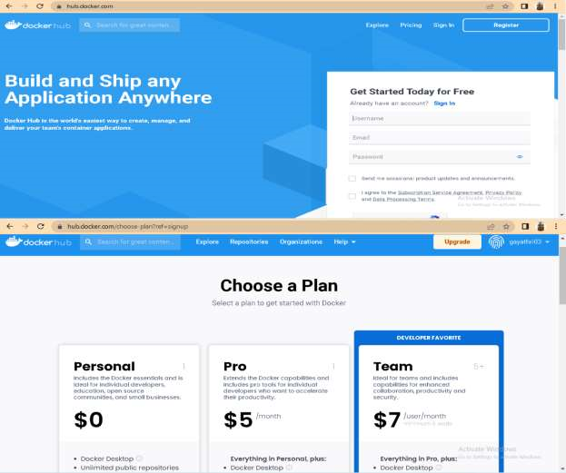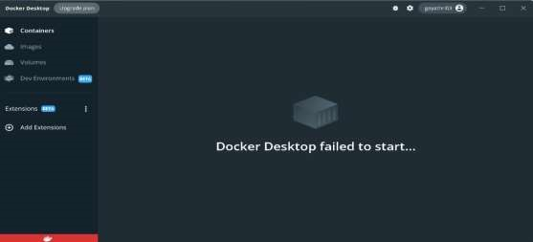

**Step 3. Open Docker Desktop and start creating containers and images**